Ray in Space
# Source: AI Source: Provided by: [Data Path: Persons Table -> ID Column: 1, Name_En Column: Motasem Essam] -> From: [ChatGPT] on [7/25/2026]
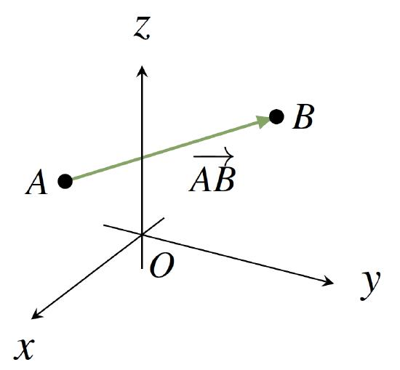
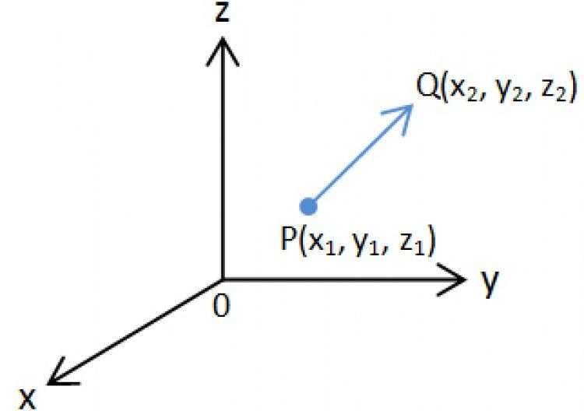
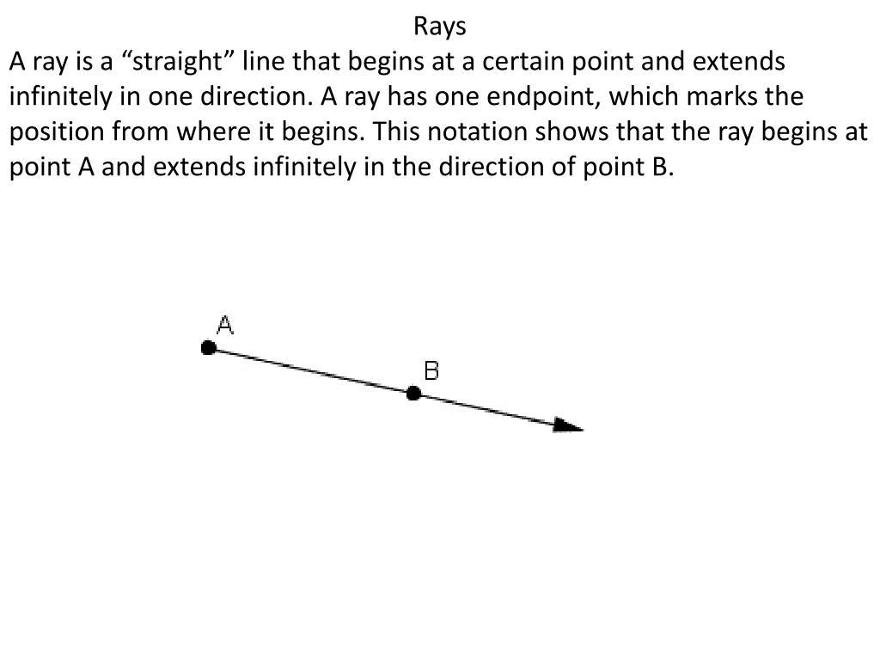

Definition
# Source: AI Source: Provided by: [Data Path: Persons Table -> ID Column: 1, Name_En Column: Motasem Essam] -> From: [ChatGPT] on [7/25/2026]
A ray in space is a part of a straight line in three-dimensional space that begins at a fixed point, called the endpoint, and extends infinitely in one direction.
A ray has one endpoint but no endpoint in the direction in which it continues indefinitely. It has a definite direction and lies along a straight line in 3D space.
If $A$ is the endpoint and $B$ is another point on the ray, the ray is written as:
$$\boxed{\overset{→}{AB}}$$
The ray begins at $A$, passes through $B$, and continues beyond $B$ in the same direction.

Simple definition
# Source: AI Source: Provided by: [Data Path: Persons Table -> ID Column: 1, Name_En Column: Motasem Essam] -> From: [ChatGPT] on [7/25/2026]
A ray in space is a straight path that starts at one point and continues forever in one direction through three-dimensional space.
Ray $\overset{→}{AB}$: A is the endpoint; the arrow shows its direction.

Key characteristics
# Source: AI Source: Provided by: [Data Path: Persons Table -> ID Column: 1, Name_En Column: Motasem Essam] -> From: [ChatGPT] on [7/25/2026]
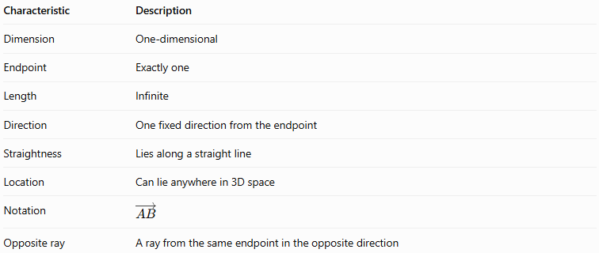
Characteristic | Description
Dimension | One-dimensional
Endpoint | Exactly one
Length | Infinite
Direction | One fixed direction from the endpoint
Straightness | Lies along a straight line
Location | Can lie anywhere in 3D space
Notation | $$\overset{→}{AB}$$
Opposite ray | A ray from the same endpoint in the opposite direction
A ray has no terminal endpoint in its direction of travel. Although any two points on it are separated by a finite distance, the ray itself extends infinitely.

Types and examples of rays in space

A. Ray along a coordinate axis
# Source: AI Source: Provided by: [Data Path: Persons Table -> ID Column: 1, Name_En Column: Motasem Essam] -> From: [ChatGPT] on [7/25/2026]
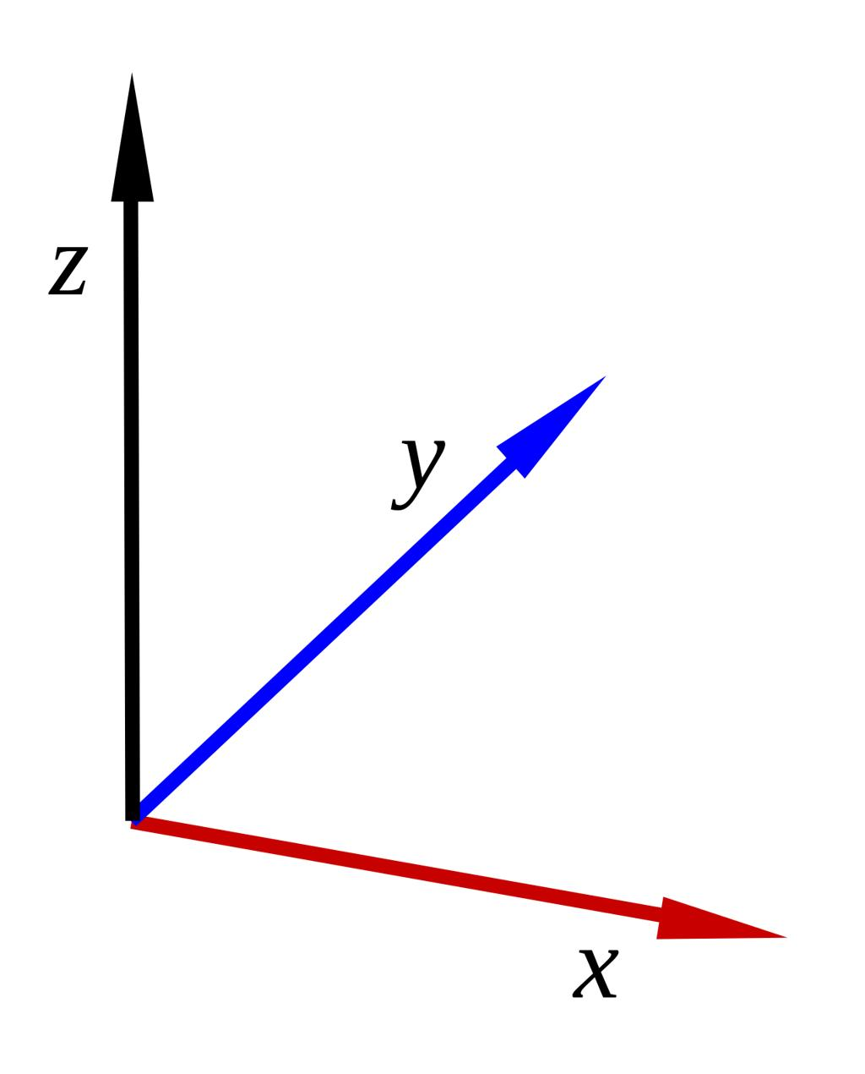
A ray can begin at the origin and extend along one of the coordinate axes.
For example, a ray starting at $O=\left(0,0,0\right)$ and pointing along the positive $x$-axis can be represented by:
$$\left(x,y,z\right)=\left(t,0,0\right), t≥0$$
Here, the endpoint is the origin and the ray extends toward positive $x$.

B. Ray in an arbitrary direction
# Source: AI Source: Provided by: [Data Path: Persons Table -> ID Column: 1, Name_En Column: Motasem Essam] -> From: [ChatGPT] on [7/25/2026]
A ray can point in any direction in space, not only along the coordinate axes.
If its endpoint is $A$ and its direction vector is $d=\left(a,b,c\right)$, then:
$$r\left(t\right)=A+td, t≥0$$
The parameter $t$ starts at zero and increases indefinitely.

C. Ray starting at a vertex of a solid
# Source: AI Source: Provided by: [Data Path: Persons Table -> ID Column: 1, Name_En Column: Motasem Essam] -> From: [ChatGPT] on [7/25/2026]
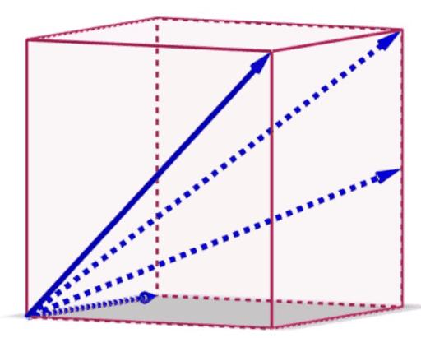
A ray may begin at a vertex of a cube, pyramid, or another solid and extend outward or in a chosen direction.
Such a ray is not necessarily an edge of the solid. An edge is a finite boundary segment, while the ray continues indefinitely.

D. Ray lying on a face or plane
# Source: AI Source: Provided by: [Data Path: Persons Table -> ID Column: 1, Name_En Column: Motasem Essam] -> From: [ChatGPT] on [7/25/2026]
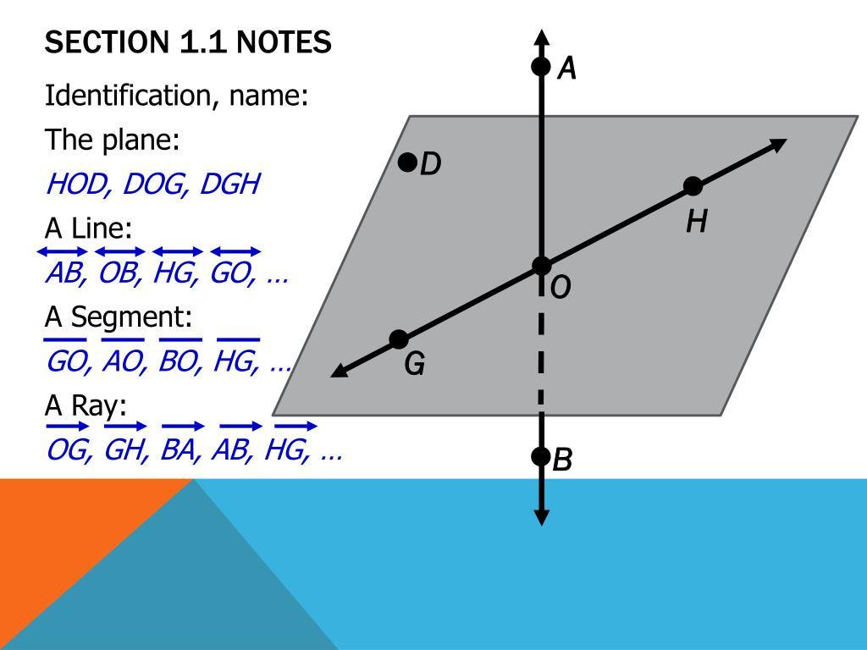
A ray can lie entirely within a plane that forms a face of a solid, or within any other plane in space.
For example, a ray on the $xy$-plane has $z=0$:
$$\left(x,y,z\right)=\left(x_{0},y_{0},0\right)+t\left(a,b,0\right)$$
where $t≥0$ and $\left(a,b\right)≠\left(0,0\right)$.

Mathematical representations

A. Vector equation of a ray
# Source: AI Source: Provided by: [Data Path: Persons Table -> ID Column: 1, Name_En Column: Motasem Essam] -> From: [ChatGPT] on [7/25/2026]
Let the endpoint be $A=\left(x_{0},y_{0},z_{0}\right)$, and let its nonzero direction vector be $d=\left(a,b,c\right)$.
The vector equation is:
$$\boxed{r\left(t\right)=A+td, t≥0}$$
The restriction $t≥0$ is essential: it selects the ray starting at $A$, rather than the complete line extending in both directions.

B. Parametric equations
# Source: AI Source: Provided by: [Data Path: Persons Table -> ID Column: 1, Name_En Column: Motasem Essam] -> From: [ChatGPT] on [7/25/2026]
Expanding the vector equation gives:
$$\boxed{\begin{aligned}x&=x_{0}+at \\ y&=y_{0}+bt \\ z&=z_{0}+ct\end{aligned} t≥0}$$
These equations describe every point on the ray.

C. Ray defined by two points
# Source: AI Source: Provided by: [Data Path: Persons Table -> ID Column: 1, Name_En Column: Motasem Essam] -> From: [ChatGPT] on [7/25/2026]
Suppose the ray starts at $A=\left(x_{1},y_{1},z_{1}\right)$ and passes through $B=\left(x_{2},y_{2},z_{2}\right)$, where $A≠B$.
Its direction vector is:
$$d=B-A$$
$$d=\left(x_{2}-x_{1}, y_{2}-y_{1}, z_{2}-z_{1}\right)$$
Therefore, the ray is:
$$\boxed{r\left(t\right)=A+t\left(B-A\right), t≥0}$$
When $t=0$, the point is $A$. When $t=1$, it is $B$. When $t>1$, it lies beyond $B$ in the ray's direction.

D. Distance from the endpoint
# Source: AI Source: Provided by: [Data Path: Persons Table -> ID Column: 1, Name_En Column: Motasem Essam] -> From: [ChatGPT] on [7/25/2026]
For a point on the ray with position vector $r\left(t\right)=A+td$, its distance from the endpoint is:
$$\boxed{AP=t\left\|d\right\|, t≥0}$$
This expression assumes the direction vector $d$ is not the zero vector.

Worked examples
# Source: AI Source: Provided by: [Data Path: Persons Table -> ID Column: 1, Name_En Column: Motasem Essam] -> From: [ChatGPT] on [7/25/2026]
Example 1: Write the equation of a ray
A ray begins at $A=\left(1,2,3\right)$ and passes through $B=\left(4,6,5\right)$. Find its vector and parametric equations.
Step 1: Find the direction vector.
$$d=B-A=\left(4-1,6-2,5-3\right)$$
$$d=\left(3,4,2\right)$$
Step 2: Write the vector equation.
$$\boxed{r\left(t\right)=\left(1,2,3\right)+t\left(3,4,2\right), t≥0}$$
Step 3: Write the parametric equations.
$$\boxed{\begin{aligned}x&=1+3t \\ y&=2+4t \\ z&=3+2t\end{aligned} t≥0}$$
Answer: These equations describe the ray starting at $A$, passing through $B$, and extending indefinitely beyond $B$.
Example 2: Find a point on a ray
A ray is given by:
$$r\left(t\right)=\left(2,1,4\right)+t\left(1,2,3\right), t≥0$$
Find the point corresponding to $t=2$.
Step 1: Substitute $t=2$.
$$x=2+2\left(1\right)=4$$
$$y=1+2\left(2\right)=5$$
$$z=4+2\left(3\right)=10$$
Answer:
$$\boxed{P=\left(4,5,10\right)}$$
Example 3: Determine whether a point lies on a ray
Consider the ray:
$$r\left(t\right)=\left(1,1,1\right)+t\left(2,3,4\right), t≥0$$
Does $P=\left(5,7,9\right)$ lie on the ray?
Step 1: Compare the coordinates.
$$1+2t=5⇒t=2$$
$$1+3t=7⇒t=2$$
$$1+4t=9⇒t=2$$
Step 2: Check the parameter.
All three coordinates give $t=2$, which satisfies $t≥0$.
Answer: Yes. $\boxed{P\text{ lies on the ray}}$.
Example 4: Distinguish a ray from a line
A line passes through $A=\left(0,0,0\right)$ in direction $d=\left(1,2,3\right)$.
- The ray starting at $A$ uses $t≥0$.
- The complete line uses $t∈R$, meaning $t$ can be positive, zero, or negative.
For $t=-1$, the line includes the point $\left(-1,-2,-3\right)$, but the ray starting at the origin in the positive direction does not.
Conclusion: The parameter restriction determines whether the equation describes a ray or a complete line.

Comparison with related geometric concepts
# Source: AI Source: Provided by: [Data Path: Persons Table -> ID Column: 1, Name_En Column: Motasem Essam] -> From: [ChatGPT] on [7/25/2026]
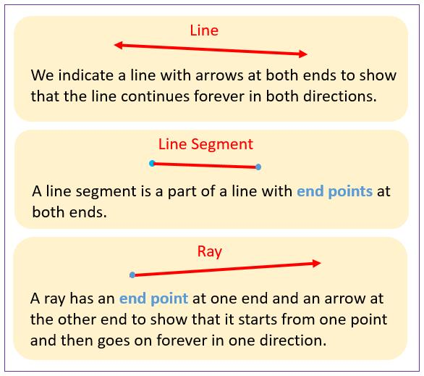
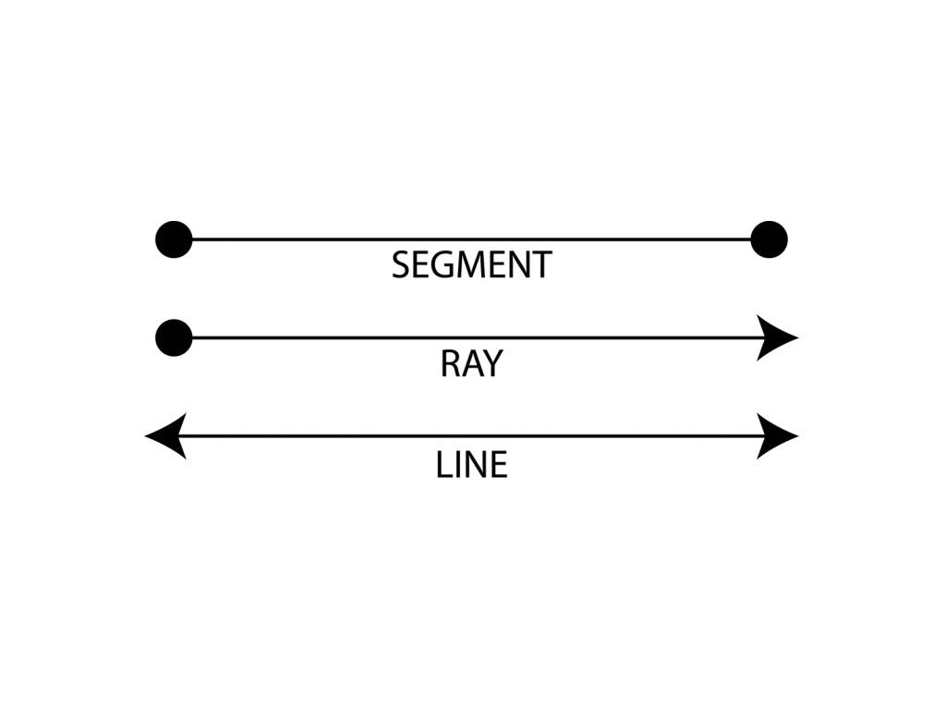
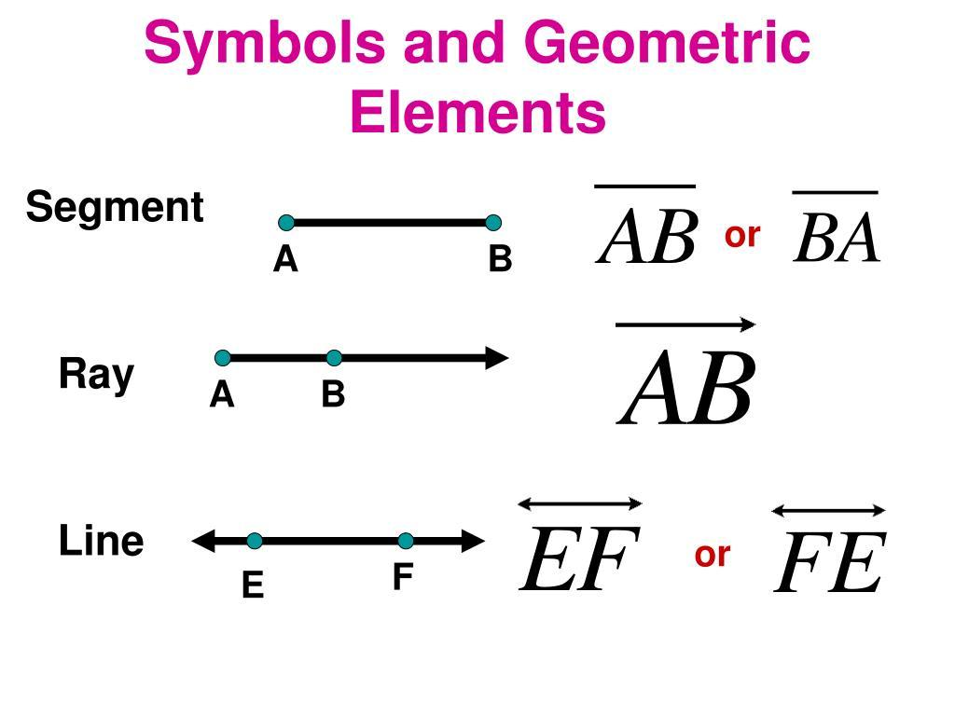
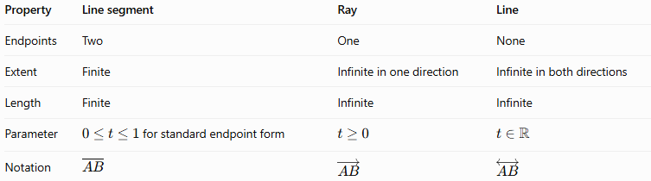
Property | Line segment | Ray | Line
Endpoints | Two | One | None
Extent | Finite | Infinite in one direction | Infinite in both directions
Length | Finite | Infinite | Infinite
Parameter | $0≤t≤1$ for standard endpoint form | $$t≥0$$ | $$t∈R$$
Notation | $$\overline{AB}$$ | $$\overset{→}{AB}$$ | $$\overset{↔}{AB}$$
Important: A ray is defined by its endpoint and direction. Reversing the endpoint and direction creates a different ray, even if both rays lie on the same line.

Practical applications
# Source: AI Source: Provided by: [Data Path: Persons Table -> ID Column: 1, Name_En Column: Motasem Essam] -> From: [ChatGPT] on [7/25/2026]
- Computer graphics: representing light rays and directional paths in 3D scenes.
- Optics: modeling the direction in which light travels from a source.
- Geometry and measurement: describing a straight path that starts at a known point.
- Robotics: representing a direction of travel from a fixed position.
- Ray casting: testing which objects a directed ray encounters in a 3D environment.
In physical applications, rays are mathematical idealizations: real light beams and moving objects do not necessarily extend infinitely.

Key points
# Source: AI Source: Provided by: [Data Path: Persons Table -> ID Column: 1, Name_En Column: Motasem Essam] -> From: [ChatGPT] on [7/25/2026]
- A ray in space has exactly one endpoint.
- It extends infinitely in one direction.
- It is represented by $\overset{→}{AB}$, with $A$ as the endpoint.
- Its vector equation is $r\left(t\right)=A+td$, with $t≥0$.
- A ray can lie along an axis, within a plane, or in an arbitrary direction through space.
- A ray differs from a segment because a segment is finite, and from a line because a line extends in both directions.

Conclusion
# Source: AI Source: Provided by: [Data Path: Persons Table -> ID Column: 1, Name_En Column: Motasem Essam] -> From: [ChatGPT] on [7/25/2026]
A ray in space is a fundamental geometric object used to represent a straight, one-directional path in three dimensions. Its endpoint determines where it begins, and its direction vector determines how it extends. Vector and parametric equations make it possible to describe and analyze rays precisely in solid geometry.

